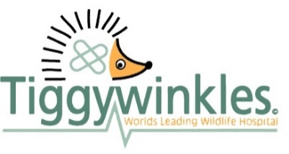

Job Description
Job Title: Communications Officer
Responsible to: Director of Operations
Job Purpose: To ensure the brand visual identity, voice and ethos is embedded within all products, content and activities. Produce content and oversee our website and social media channels, the newsletter and act as first point of contact for all press and media enquiries, visits and filming.

Key Accountabilities
Be the first port of call for brand in product development, as and when new projects or workstreams are introduced, ensuring colleagues from all departments fully understand and appreciate the importance of brand consistency.
Design and implement a visual brand audit system with the aim of maintaining compliance, putting the system into operation and making any necessary improvements.
Assist the Visitor Centre Manager and other colleagues with product development and design including information leaflets, guides, signage, Christmas card design and QR code placement.
Along with the Directors, build and nurture effective relationships with corporate donors and supporters, briefing and embedding our brand in all new relationships.
Manage and maintain our brand trademarks.
Produce written, photographic and video content for social media including Facebook, X (formally Twitter), Instagram, TikTok and Threads. Monitor and respond to private messages on social media channels.
Manage the production of the newsletter. Commission and edit contributor’s work. Write articles. Liaise with designers and printers ensuring that the newsletter is sent out keeping to deadlines. Produce accurate reports for address labels.
Attend animal rescues and releases from time-to-time to collect photos and videos for newsletters, the website and social media.
Take responsibility for the established legacy advertising system – in printed and online forms
Be the first point of contact for press and media enquiries and assist the directors in this area wherever necessary.
Deal with guests and visitors including television crews and VIPs, monitoring their safety and welfare in a professional, courteous and friendly manner. Chaperoning crews as necessary.
Take responsibility for ongoing website management, using WordPress.
Conduct or oversee visual website audits to review the information and materials for compliance and improvements.
Hold and administer the photographic stock and provide items as requested.
Produce and print promotional leaflets, fact sheets and other branded material, assisting in design wherever necessary.
Monitor stock required for the role, making sure that stock is reordered as needed.
Attend to other jobs as required by the Directors.
Comply with all policies, including safeguarding requirements.

Tiggywinkles, Aston Road, Haddenham, Bucks, HP17 8AF
Tel: 01844 292292 Email: mail@tiggywinkles.org www.tiggywinkles.com

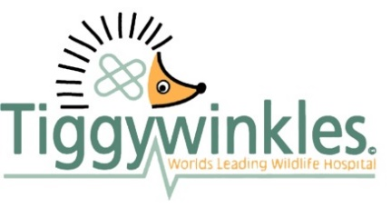
Person Specification

Job Title: Communications Officer

Attributes | Essential | Desirable
Attainments /  Qualifications | Computer literate including Microsoft Word, Microsoft Outlook, Adobe Photoshop, InDesign, Premier Pro and WordPress. | Conversant with Canva.
Previous Experience | Administration experience.  Social Media experience. | Video editing experience.  Telephone/customer facing experience.  Experience dealing with the press.  Photography experience.
Skills | Excellent storytelling, copywriting and proof-reading skills.  Excellent verbal and written communication skills.  Ability to communicate effectively at all levels.  Able to organise own workload. | Good problem solving skills.
Disposition | Able to take responsibility for own work and do what is necessary to get the best possible results for the Charity and our patients.  A positive disposition and effective problem solving skills.  Ability to work under own initiative and as part of a team.  Ability to remain calm when faced with emergency situations and to work within tight deadlines. | Full valid driving licence.  An interest in and understanding of British wildlife.  Friendly, caring and approachable attitude.

Tiggywinkles, Aston Road, Haddenham, Bucks HP17 8AF
Tel: 01844 292292 www.tiggywinkles.com

