
www.tiggywinkles.com

Application Form
Application for the Position of: Baby Bird and Mammal Feeder

Please circle/highlight below the vacancy/vacancies you wish to apply for:

Vacancy #1 / Vacancy #2

Personal Details
Title: | Forename: | Surname: |  | Pronouns:
Address:

Post code:
Telephone Number: |  | Mobile Number:
Email Address:
Do you have a clean current driving licence?
Skills and Qualifications
Educational establishments attended (including schools, colleges etc.), awarding institute or professional body:

Attainment level achieved, specifying relevant grades or grade of membership:

Computer literacy (please specify software and level of competence):

Experience of working with animals:

Experience of working with the general public:

Have you worked/volunteered for any charities, please give details:

Hobbies/leisure interests:

Any other Skills:

Employment Details
Present Employer:  Address:  Dates:  Job Title:  Hours:  Salary: |  |  | Previous Employer:  Address:  Dates:  Job Title:  Hours:  Salary:  Reason for Leaving:  Leaving Date:
Previous Employer:  Address:  Dates:  Job Title:  Hours:  Salary:  Reason for Leaving:  Leaving Date: |  |  | Previous Employer:  Address:  Dates:  Job Title:  Hours:  Salary:  Reason for Leaving:  Leaving Date:
Gaps in employment
Please tell us about any gaps in your employment history
From | To |  | Reason
Public Duties
Do you have armed service/public duty commitments? YES/NO
(e.g. are you a member of the TA/ a JP/ a councillor, etc.)
If YES, please give details:

General Information
Where did you hear about this vacancy?

Do you support Hunting / shooting / falconry?

Right to Work in the UK

Are you currently eligible for employment in the UK? Yes/No

Please state what documentation you can provide to demonstrate this, e.g. British passport/EU Settlement Status/full birth certificate/passport or travel document showing an authorisation to reside and work in the UK.

Declaration of Criminal Convictions

The nature of the work for which you are applying will bring you into direct contact with children and young people, therefore this post will require a DBS check and once an applicant has been short listed we will ask: -

Do you have any convictions, cautions, reprimands or final warnings that are not “protected” as defined by the Rehabilitation of Offenders Act 1974 (Exceptions) Order 1975 (as amended in 2013). You will be supplied with a confidential self-disclosure form.

The amendments to the exceptions order 1975 (2013) provide that certain spent convictions and cautions are “protected” and are not subject to disclosure to employers, and cannot be taken into account.
Guidance and criteria on the filtering of these cautions and convictions can be found on the Disclosure and Barring Service website.

Additional Information
Any other information you would like to give that you feel would assist in your application, including why would you like to work at Tiggywinkles (add extra sheet if necessary)

Health and Wellbeing
The Health and Wellbeing of our employees is of paramount importance to us at Tiggywinkles.
Please note the following restrictions and cautions regarding working with us:

Tetanus is a serious bacterial infection that can be spread by animal bites. Given that working with us means working in close proximity to wild animals an up to date tetanus vaccination is a mandatory requirement for all employees.

If you are invited for a second stage interview, which may involve some hands-on experience, you must ensure that your tetanus vaccination (which lasts for 10 years) is up to date. Please confirm with your GP that this is the case prior to attendance at a second stage interview. This is your responsibility to do so.
Further confirmation would be required should you receive a job offer from us.

Many roles here at Tiggywinkles involve physical exertion, including bending and lifting heavy items e.g. bags of feed, bedding material and cleaning enclosures/handling animals in cages at different heights. You sometimes need to be agile in order to avoid being injured by our patients, which are wild animals.

We provide full training regarding how to respond and handle the wild animals in our care but this does not detract from the need to be agile in order to remain safe.

Much of our work involves handling animals, feed and bedding, as well as chemical substances used to ensure our animal enclosures are kept clean. Latex gloves are therefore worn by our employees in order to protect their hands.

Reasonable adjustments are always considered for those who may have a medical, physical impairment, a phobia or an allergy and where our assessment is that they would be safe, practical and reasonable, we are keen to accept them.

Data Protection Statement
All of the information collected in this form is necessary and relevant to the performance of the job applied for. We will use the information provided by you on this form, by the referees you have noted, and the educational institutions with whom we may undertake to verify your qualifications, for recruitment purposes only. The Company will treat all personal information with the utmost confidentiality and in line with current data protection legislation. We rely on the lawful basis of legal obligation and the performance of a contract to process the information provided by you in this form.

Should you be successful in your application, the information provided, and further information which will be gathered at the relevant time, will be subsequently used for the administration of your employment and in relation to any legal challenge which may be made regarding our recruitment practices.

For more information on how we use the information you have provided, please see our Job Applicant Privacy Notice (GDPR compliance). This is available on our website Tiggywinkles.com, on the Help us page, under ‘vacancies’, or to request an email or printed version, please email us at gpdr@tiggywinkles.org

Declaration
I declare to the best of my knowledge and belief, all particulars I have given in all parts of this application form are complete and true. I understand that any false declaration or misleading statement or a significant omission may disqualify me from employment and render me liable to dismissal. I understand that any job offer is subject to references, checks on relevant qualifications, employment eligibility and criminal convictions if this is required for the role, a probationary period and (if the organisation believes it appropriate) a medical report, all of which must be deemed by the organisation as satisfactory.

Name:

Signature: Date:

On completion, please return this form to:

Ms Steph Broadribb

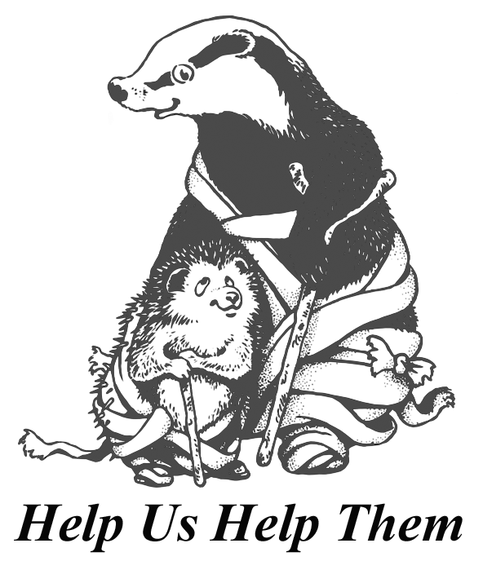
Tiggywinkles, The Wildlife Hospital

Aston Road
Haddenham
Bucks HP17 8AF

OR

recruitment@tiggywinkles.org

