

Visitor Centre Volunteer Application Form

Personal Details
Title: | Forename: |  |  |  | Surname:
Address:
Post code:
Telephone Number: |  | Mobile Number:
Email Address:

Are you over the age of 16 years old? YES / NO
Our Visitor Centre is open 7 days a week between 10am and 4pm. What days/hours would you be willing to offer to Tiggywinkles?

Animal Work
Please detail any relevant experience of working with animals:

Charity Work
Please detail all current or previous charity involvement:

Employment Details
Current or last employer  Company:  Address:  Dates:  Job Title:  Duties:  Hours: |  |  | Previous employer  Company:  Address:  Dates:  Job Title:  Duties:  Hours:
Relevant Medical Details
Emergency Contact Name:  Relationship: |  |  | Contact Number:
Doctor’s Name:  Surgery Name: |  |  | Surgery Telephone Number:  Surgery Address:
Tetanus is a serious bacterial infection that can be spread by animal bites. Given that working with us means working in close proximity to wild animals, an up-to-date tetanus vaccination is a mandatory requirement for all volunteers. If you are invited to join the team, it will require hands-on training, so you must ensure that your tetanus vaccination (which lasts for 10 years) is up to date. Please confirm with your GP that this is the case. This is your responsibility to do so.

Date of Last Vaccination: _______________
Some roles can be very active and involve bending and lifting. In particular, lifting and handling heavy items such as bags of feed are intrinsic functions of the job for which you have applied.
Please indicate below whether you have any medical condition(s) which may prevent you from carrying out these intrinsic functions, e.g. bad back.
Please also indicate if you consider that there are any reasonable adjustments which could be made to allow you to carry out these intrinsic functions, notwithstanding your medical condition(s).

Medical Condition: |  |  | Reasonable Adjustments Required:
The work involves working with lots of different species of animals, handling feed and bedding materials such as hay and straw and cleaning cages with appropriate chemical substances; all of which are intrinsic functions for the role. Latex gloves are also usually worn by staff.
Please indicate below whether you have any medical condition or any phobia or allergies that may be relevant to this position. Please also indicate if you consider that there are any reasonable adjustments which could be made to allow you to carry out these intrinsic functions, notwithstanding your medical condition, phobia or allergy.

Medical Condition/Phobia/Allergy: |  |  | Reasonable Adjustments Required:
Leisure Time
Hobbies/leisure interests:

How did you come to hear about us?
Do you support Hunting / shooting / falconry?
Any other information you would like to give that you feel is relevant to this voluntary position:

Data Protection Statement
All of the information collected in this form is necessary and relevant to the performance of the job applied for. We will use the information provided by you on this form, by the referees you have noted, and the educational institutions with whom we may undertake to verify your qualifications, for recruitment purposes only. The Company will treat all personal information with the utmost confidentiality and in line with current data protection legislation. We rely on the lawful basis of legal obligation and the performance of a contract to process the information provided by you in this form.

Should you be successful in your application, the information provided, and further information which will be gathered at the relevant time, will be subsequently used for the administration of your employment and in relation to any legal challenge which may be made regarding our recruitment practices.

For more information on how we use the information you have provided, please see our Job Applicant Privacy Notice (GDPR compliance). This is available on our website Tiggywinkles.com, on the Help Us page, under ‘vacancies’, or to request an email or printed version, please email us at gpdr@tiggywinkles.org

Declaration
Declaration of Criminal Convictions
Many of our volunteer roles bring volunteers into direct contact with children and young people, therefore for these roles would require a DBS check and once an applicant has been shortlisted we will ask: -

Do you have any convictions, cautions, reprimands or final warnings that are not “protected” as defined by the Rehabilitation of Offenders Act 1974 (Exceptions) Order 1975 (as amended in 2013). You will be supplied with a confidential self-disclosure form if you are shortlisted for a relevant role.

The amendments to the exceptions order 1975 (2013) provide that certain spent convictions and cautions are “protected” and are not subject to disclosure to employers, and cannot be taken into account.
Guidance and criteria on the filtering of these cautions and convictions can be found on the Disclosure and Barring Service website.

I declare to the best of my knowledge and belief, all particulars I have given in all parts of this application form are complete and true. I understand that any false declaration or misleading statement or a significant omission may disqualify me from volunteering and render me liable to dismissal. I understand that any role offer is subject to professional references, and also a criminal convictions check if this is required, all of which must be deemed by the organisation as satisfactory.

Signed: |  |  |  | Date:

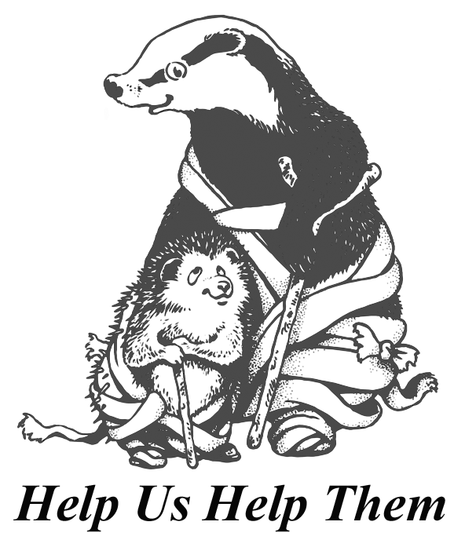
Please complete this form and send to:

Steph Broadribb, HR Officer

Tiggywinkles, Aston Road, Haddenham, Bucks HP17 8AF

Or to recruitment@tiggywinkles.org

Tel: 01844 292292
www.tiggywinkles.com

Office Use Only
Date Received |  | Date of Initial Contact
Start Date: | Area:
Process | Date Completed |  | Completed By
Personnel database updated
Induction paperwork received
Finish Date
Personnel database updated

